Procedures for instructors who teach in Summer Session

Some faculty who are being hired to teach in the Summer Session will need to be transferred to Summer Session and hired as Teacher Summer Programs. This only applies to faculty in the following categories:
- Part-time faculty who only teach during the academic year, i.e. August or September through May
- Full-time, multi-year, non-tenured faculty who are resigning from Yale effective June 30, 2016.
The Office of Summer Session in consultation with the Provost’s Office will determine which faculty will need to be transferred. Then, a representative from Summer Session will contact the relevant department administrators to coordinate the transfer.
Note: A similar transfer will need to happen at the end of the summer if the faculty member is rehired. It is best to coordinate these arrangements at the time of the transfer to Summer Session.

Workday Instructions for Transfer

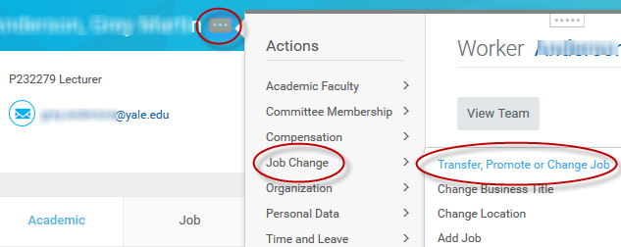
- Search for the faculty member in Workday.
- To the right of the faculty member’s name, click on the Related Actions button, hover over Job Change, then select Transfer, Promote, or Change Job.

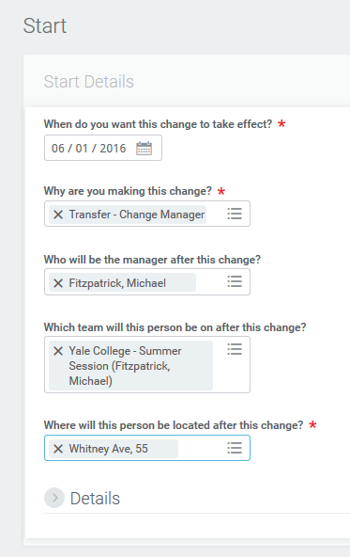
- In the Start window, enter the information as displayed in the example to the right.
Click Submit.

- What do you want to do with the opening left on your team? Select Close this headcount.
Click Next.
- In the comment field in the final review window enter the following statement, “Transferring to teach in Summer Session per request from …” and enter the name of the Summer Session contact.
Click Submit.
